

**Steps to Access Your Child’s STAAR Scores:**

If you have your child’s unique access code (6-character code) start with step 1.

If you do not have your child’s unique access code, skip to step 6.

1. Go to [www.texasassessments.com](http://www.texasassessments.com)
2. You will see this screen:

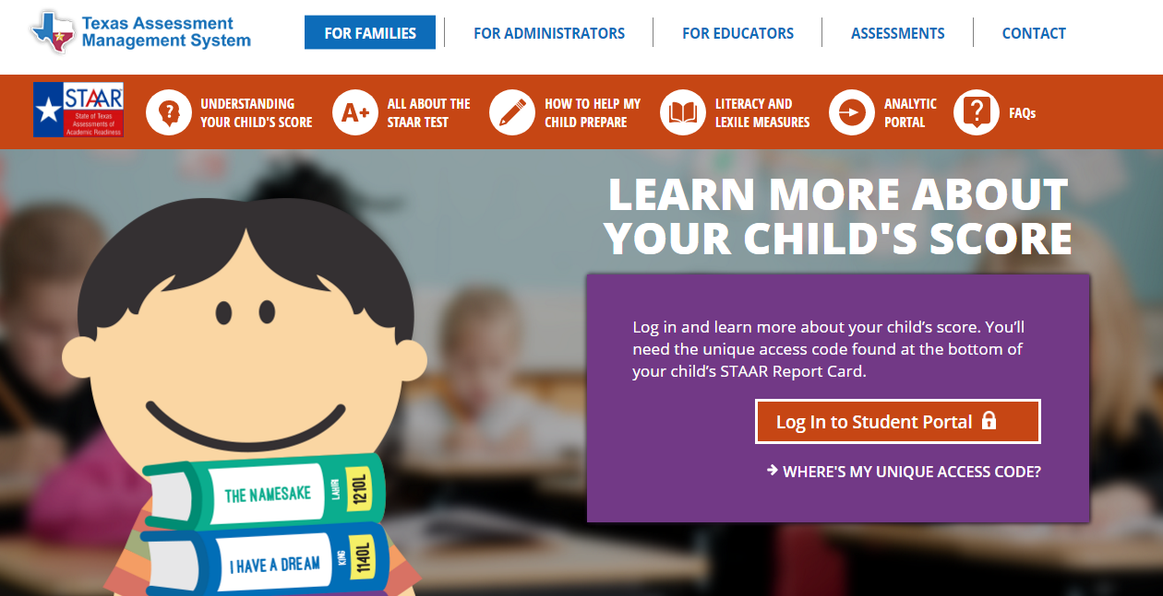

3. Select the “Log in to Student Portal”

4. You will see a screen like this:

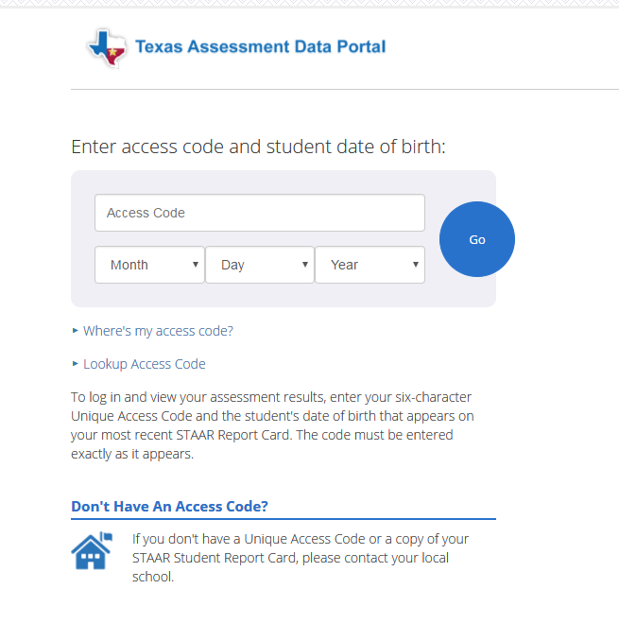

5. If you have your access code, enter the code and your child’s birthdate to view scores.

6. If you do NOT have your access code, click on “Lookup Access Code” (see circled below)

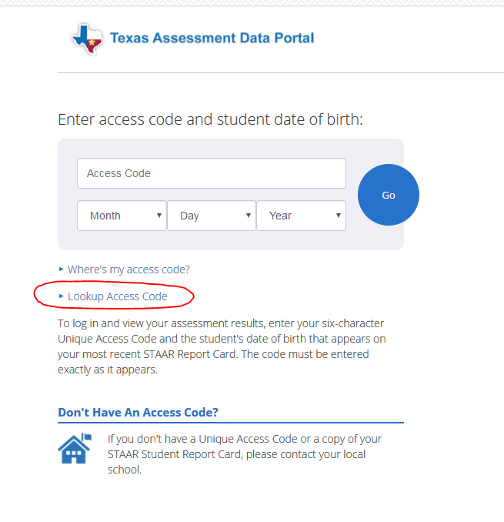

7. You will then see a screen like this:

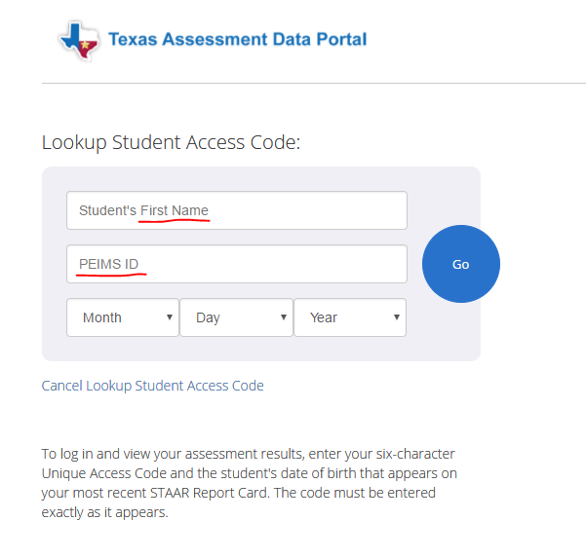

8. Enter your child’s **first name only** and his/her **social security number in the PEIMS ID field**, and **birthdate.**

9. Your code will appear. Click “go”. Be sure to write down your code for future use. The code is good for as long as your child is in a public school in Texas.

If you have questions, please contact your child’s home campus or the assessment office at 713-740-5250.

2016_Theme_Logo_PPP